**ECE 7810 ASSIGNMENT REPORT**

**(Solution of Fields by Num. Mtds I)**

**Author:** Jamiu Babatunde Mojolagbe

**Department:** Electrical and Computer Engineering

**Student ID:** #7804719

**Email:** mojolagm@myumanitoba.ca

**Course:** ECE 7810

**Homework:** 3

**Sub. Date:** November 14, 2016

**QUESTION B**

This question was implemented in the file named “**fdtdLosslessVsExact.m**”. The exact solution was implemented as derived in the solution to the “Question A” above. The code is commented and documented.

The following results were obtained:

Given that C=50pF/m and L=0.5H/m, the velocity of propagation obtained, c0 was

**Case 1:** For Courant limit, CFL = 0.9, the following graphs were obtained at voltage times: 2.2, 2.3, 2.5 and 3.5ns

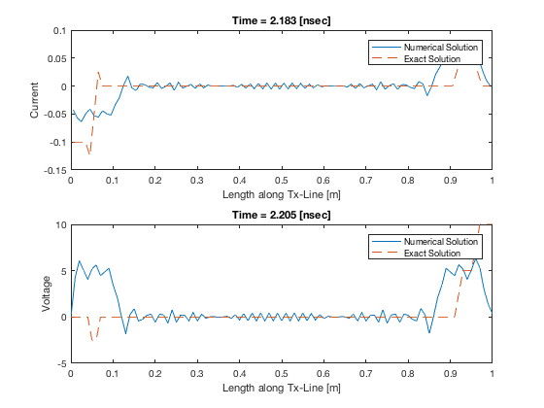

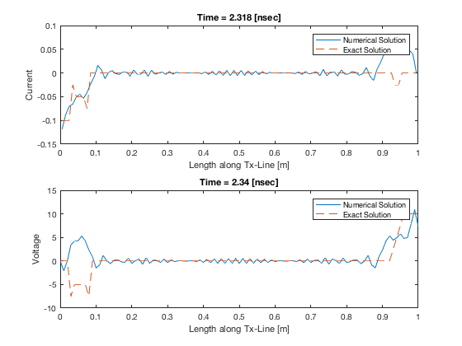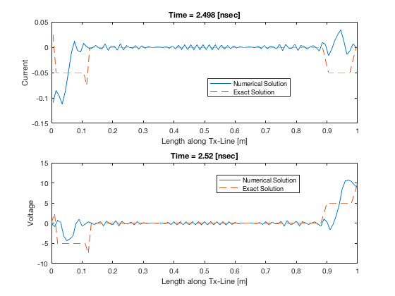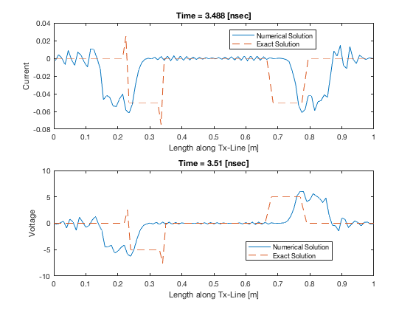

**Case 2:** For Courant limit, CFL = 1.0, the following graphs were obtained at voltage times: 2.2, 2.3, 2.5 and 3.5ns

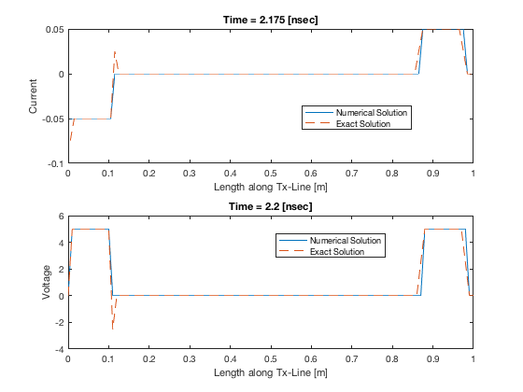

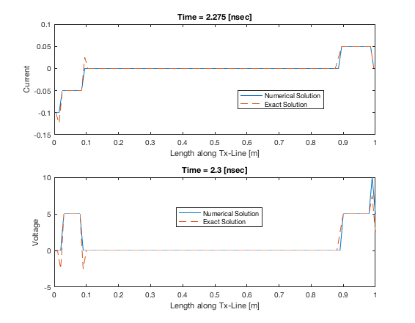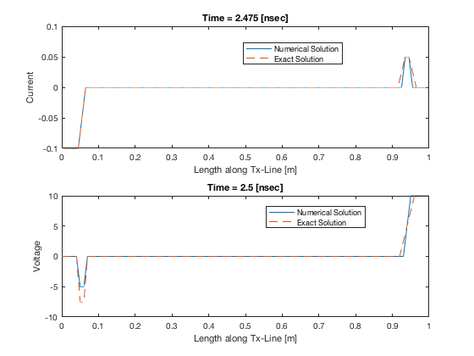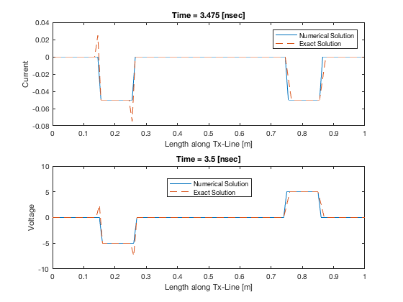

**Case 3:** For Courant limit, CFL = 1.01, the following graphs were obtained at voltage times: 2.2, 2.3, 2.5 and 3.5ns

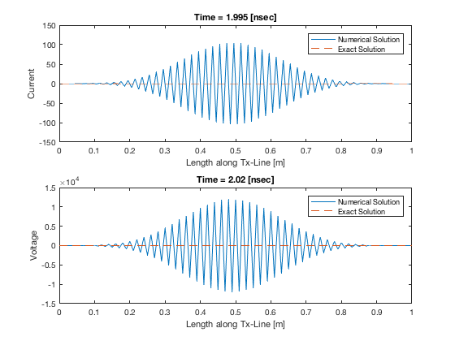

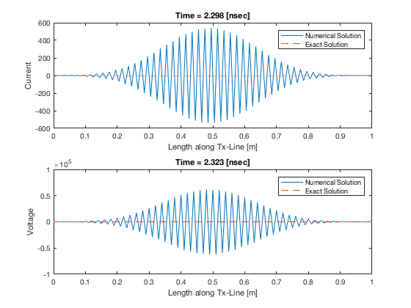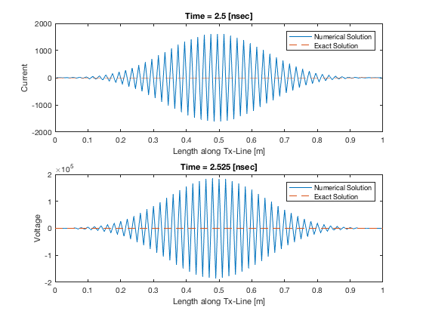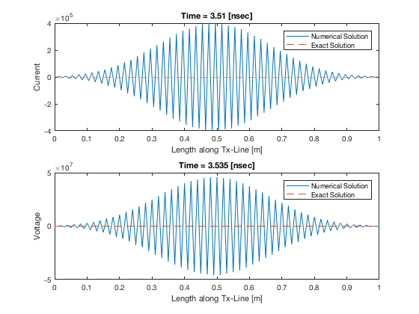

**Observation:**

As shown above, when the Courant value was less than 1.0, precisely 0.9, there seems to be partial numerical dispersion; however, when CFL was 1.0 there was stability in the wave. With Courant number greater than 1.0 the dispersion was great in the wave high instability in the wave. Again, observing the exact solution also showed that the numerical solution tends to be closer to the exact solution.

**QUESTION C**

This question’s implementation file is named “**fdtdLossy.m**”. Different cases were tested based on the different Courant numbers given. This code is well implemented and documented to easy readability. The following results were obtained:

**Case 1:** For Courant limit, CFL = 0.9, the following graph was obtained at voltage time: 2.2ns

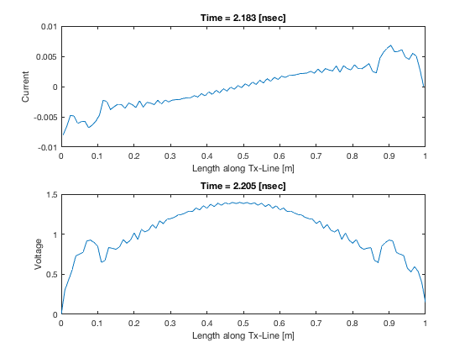

**Case 2:** For Courant limit, CFL = 1.0, the following graph was obtained at voltage time: 2.2ns

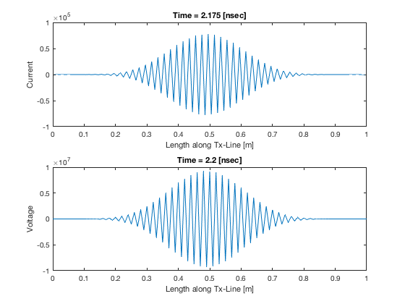

**Case 3:** For Courant limit, CFL = 1.01, the following graph was obtained at voltage time: 2.2ns

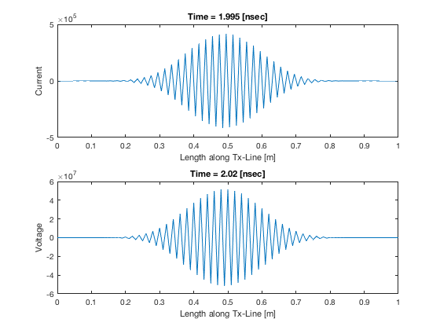

**QUESTION D**

The implementation file for this question is named “**QuestionD.m**”. Like the previous codes written, this code is well documented. The following results were obtained for different Courant values.

**Case 1:** For Courant limit, CFL = 0.9, the following graph was obtained at voltage time: 2.2ns

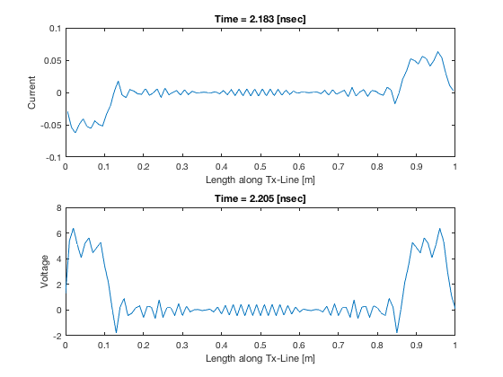

Vt_near = 0.0798 Vt_far = 0.0798

**Case 2:** For Courant limit, CFL = 1.0, the following graph was obtained at voltage time: 2.2ns

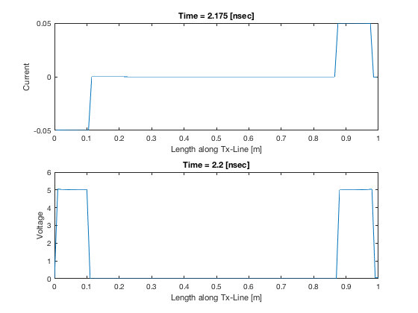

Vt_near = 0.0773 Vt_far = 0.0773

**Case 3:** For Courant limit, CFL = 1.01, the following graph was obtained at voltage time: 2.2ns

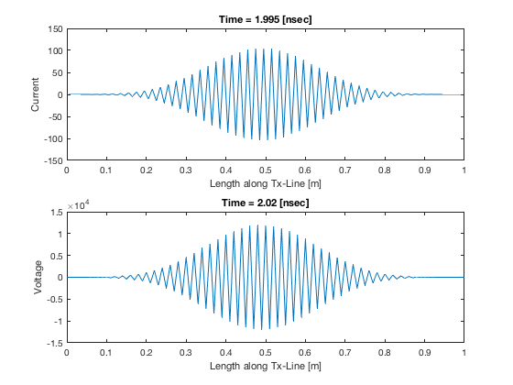

Vt_near = 0.0215 Vt_far = 0.0215

**Observation:**

As shown above, when the Courant value was less than 1.0, precisely 0.9, there seems to be partial numerical dispersion; however, when CFL was 1.0 there was stability in the wave. With Courant number greater than 1.0 the dispersion was great in the wave high instability in the wave.

**QUESTION E**

As contained in the question, the shielding was opened as given in the question as the observation points are two: one inside the shield and the other outside the shield.

For the TM case, the code was properly commented to show that the code is well understood. The following graphs were obtained from the two observation points for different incidence angles:

**Case 1:** For angle of incidence,

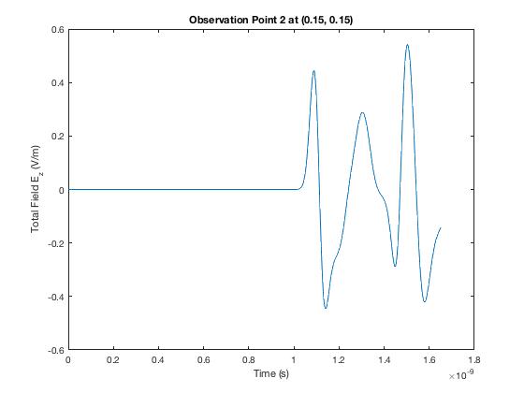 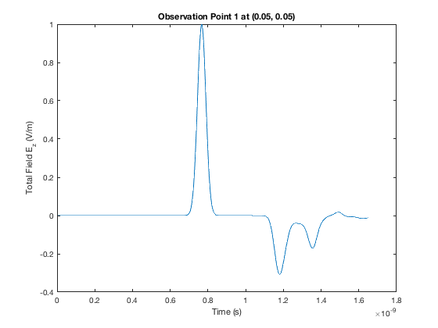

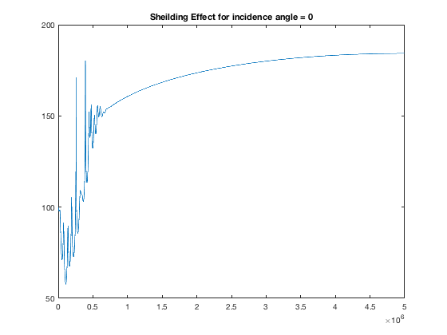

**Case 2:** For angle of incidence,

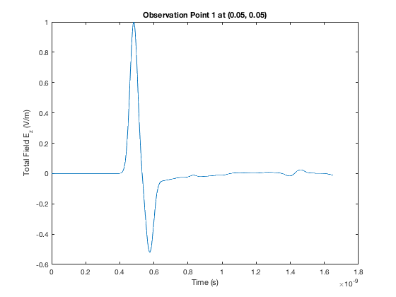 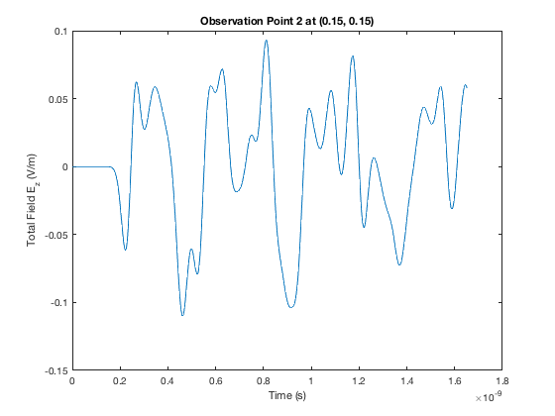

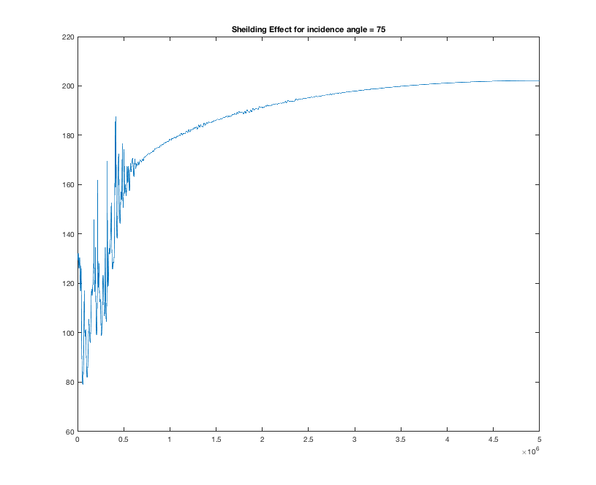

**Case 3:** For angle of incidence,

